Application Form

About the Participation:
Category:
Vocal performers;
Dance performers;
Instrumental performers
Theater troupes,
Others;

About the Group
Name of the formation:
Representing Institution:
Country, City, Location:
Group leader –
(name, education, specialty)
Tеl.:
Address:
E - mail:
Website:
Facebook:

Organizational details:
Count of the whole group:
Count of accomodations: (men/ women)
Number of nights:
Preferred dates for stay:

Технически екип: (попълнете, ако разполагате с технически лица)
Function: | Name:
* Add more fields if needed

Technical details:
Stage installation time:
Stage Disassembly Time:
Preferred Stage:
(Open / Close)
Technical requirements:
(Sound, light or other)
Need for a technical person (What kind?)

About the performance:
Title:
The author/s:
Genre:
Duration:
Short announcement:

Екип:
Director / Choreographer / Conductor -
name, education, specialty:
Author music (if any):
Arrangement (if any):
Choreography (if any):
Text (if any):
Set design: (if any)
Costumes: (if any)
Puppets (if any):
Other (if any):
* Add more fields if needed

Състав:
Name | Age | Part
1.
2.
3.
4.
5.
6.
7.
8.
9.
10.
11.
12.
13.
14.
15.
16.
17.
18.
19.
20.
* Add more fields if needed

Visualization of the halls where the festival will be held:

Indoor hall:
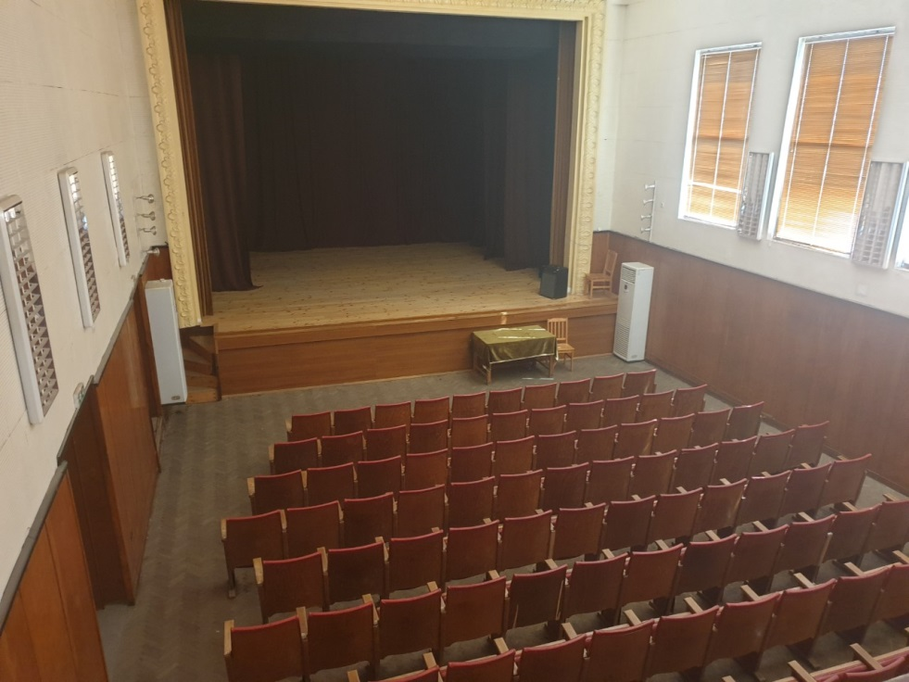

Outdoor hall:
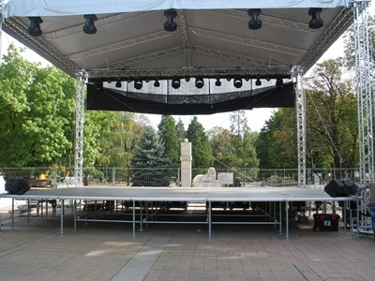

To submit requests and discuss any questions you may have::

Valentin Giasbeily – Organizer
Tel: +359 877 616208
Slavi Kostov - Organizer
Tel: +359 868 344153
E-mail: info@blacksearose.com
Website: www.blacksearose.com

